**Selenium WebDriver** is a tool for automating testing web applications. It is popularly known as Selenium 2.0. WebDriver uses a different underlying framework, while Selenium RC uses JavaScript Selenium-Core embedded within the browser which has got some limitations. WebDriver interacts directly with the browser without any intermediary, unlike Selenium RC that depends on a server. It is used in the following context:

* Multi-browser testing including improved functionality for browsers which is not well-supported by Selenium RC (Selenium 1.0).
* Handling multiple frames, multiple browser windows, pop-up’s, and alerts.
* Complex page navigation.
* Advanced user navigation such as drag-and-drop.
* AJAX-based UI elements.

**Architecture**

WebDriver is best explained with a simple architecture diagram as shown below.

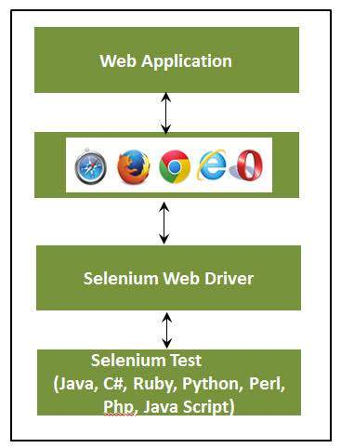

**Selenium RC Vs WebDriver**

|  |  |
| --- | --- |
| **Selenium RC** | **Selenium WebDriver** |
| The architecture of Selenium RC is complicated, as the server needs to be up and running before starting a test. | Web Driver’s architecture is simpler than Selenium RC, as it controls the browser from the OS level. |
| Selenium server acts as a middleman between the browser and Selenese commands. | WebDriver interacts directly with the browser and uses the browser's engine to control it. |
| Selenium RC script execution is slower, since it uses a JavaScript to interact with RC. | WebDriver is faster, as it interacts directly with the browser. |
| Selenium RC cannot support headless execution as it needs a real browser to work with. | WebDriver can support the headless execution. |
| It's a simple and small API. | Complex and a bit large API as compared to RC. |
| Less object-oriented API. | Purely object oriented API. |
| Cannot test mobile Applications. | Can test iPhone/Android applications. |